1. Two_moons_no_overlap

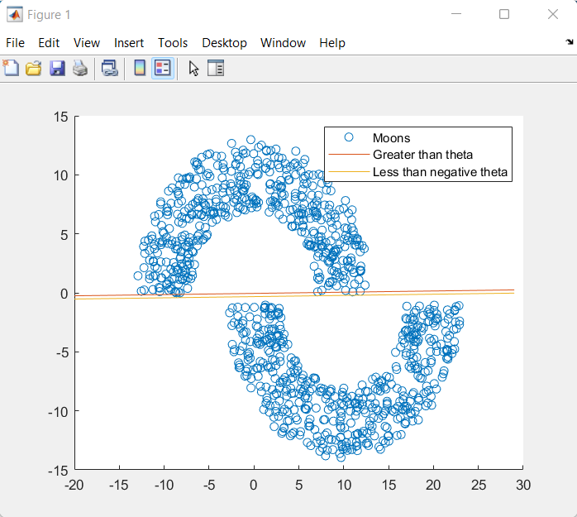

1. Two_moons_overlap

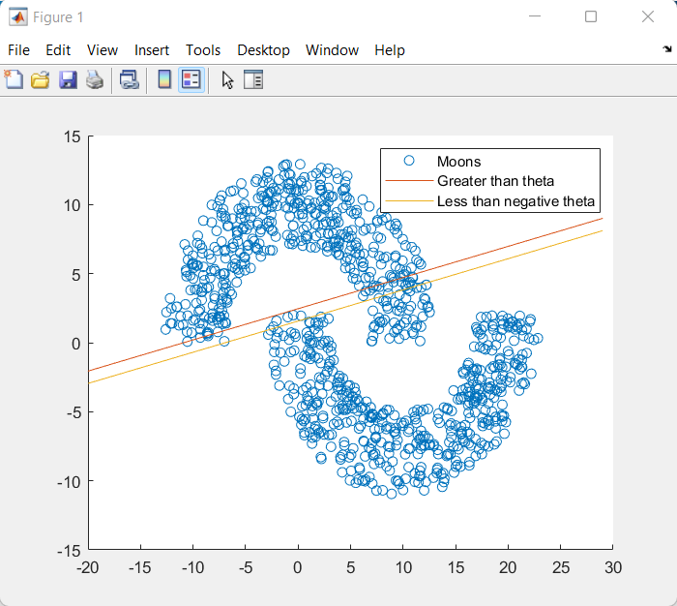

2. Two_moons_no_overlap

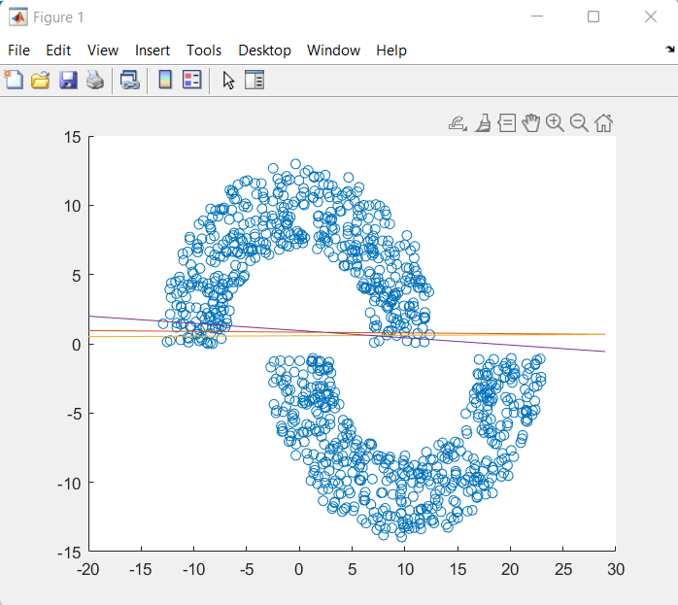

2. Two_moons_overlap2

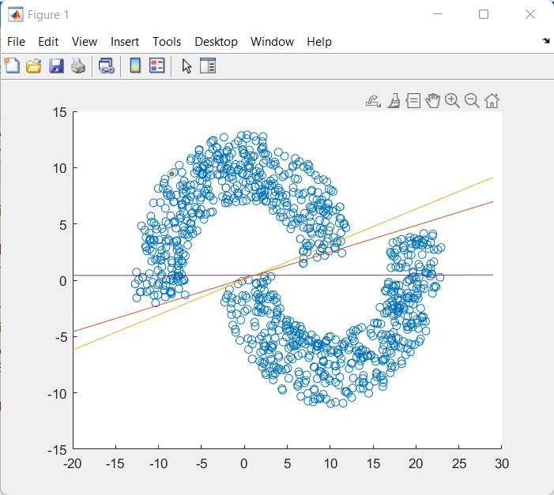

3. Two_moons_no_overlap2

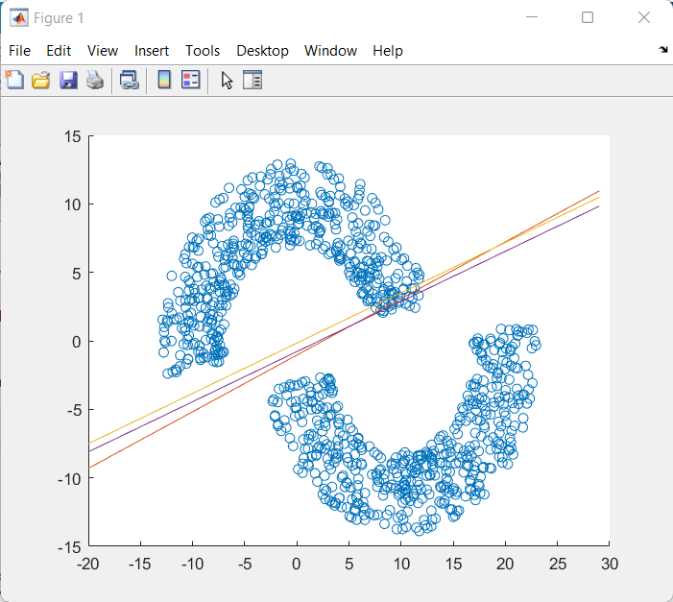

3. Two_moons_overlap3

